- SIGNAL GENERATION AND BASIC SIGNAL OPERATIONS

Experiment 1.3
Generation of Triangular and Sawtooth Signals
Aim
Generate and plot triangular and sawtooth signals.
Apparatus Required
PC with MATLAB.
Program (MATLAB)
% Generation of Triangular and Sawtooth Signals
clc;
clear;
close all;
% Time axis
t = 0:0.01:2;
% Sawtooth Signal
x1 = sawtooth(2*pi*t);
% Triangular Signal
x2 = sawtooth(2*pi*t,0.5);
% Plotting
figure;
subplot(2,1,1);
plot(t,x1,'LineWidth',2);
grid on;
title('Sawtooth Signal');
xlabel('Time (s)');
ylabel('Amplitude');
subplot(2,1,2);
plot(t,x2,'LineWidth',2);
grid on;
title('Triangular Signal');
xlabel('Time (s)');
ylabel('Amplitude');
Output Generated Graph
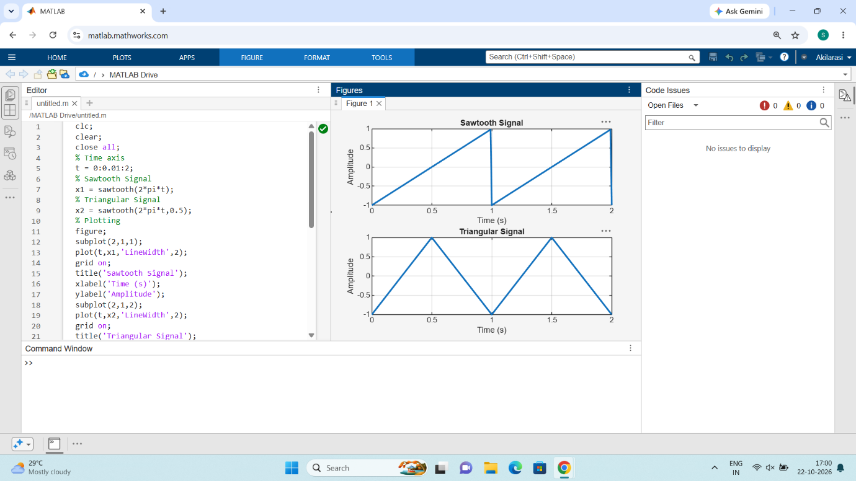

Result
Triangular wave has equal rise and fall; sawtooth shows sharp drop and gradual rise.

